Category Overview

Each recipe belongs to exactly one category or sub-category. The categories correspond to the folders in which the recipe files are stored. It is useful to store recipes for soups, desserts, poultry etc. in separate folders (categories). When you create a new category, the app creates a corresponding folder in which you can store the corresponding recipes.

In addition, you can assign one or more labels to each recipe. Examples for labels are: Italian, Asian, or Low carb.

When you start with an empty root folder, you must first create at least one category. Afterwards you can add recipes to the category.

The category overview shows all recipe categories, as well as the special folder with the recipe templates. Choose a category in order to get to a list of all corresponding recipes.

The navigation pane offers the following functions:

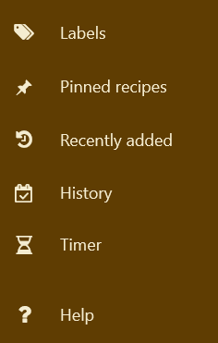

* *Labels*: This option leads you to the list of all labels. In this mode you can add, edit or delete labels. By choosing “Categories” you can switch back to the category overview:



* *Pinned recipes*: If you want to prepare a recipe in the near future you can pin it. By pressing this button, you will see the list of your pinned recipes.
* *Recently added*: Here you can see which recipes you recently added, since the last month, since the last three months, or since an arbitrary date.
* *History*: After preparing a dish you can mark the recipe as “prepared”. In this way, the app maintains a history of all prepared dishes.
* *Timer*: Opens a pane with four timers to support your cooking.

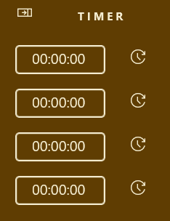

# Recipe search



From the category overview you can search across all recipes for keywords. Just enter a search term for it, and press the Enter key. This will bring you to a list of all recipes that contain the search term.

# Edit categories and labels

To create, change or delete categories display the category overview; for editing labels change to the label overview.

## Add a new category / label

To add a new category or label, click the plus-button. This opens a dialog where you can enter the name of the new category, and that allows you to choose a category image. For labels, you can also define the colors for foreground and background.

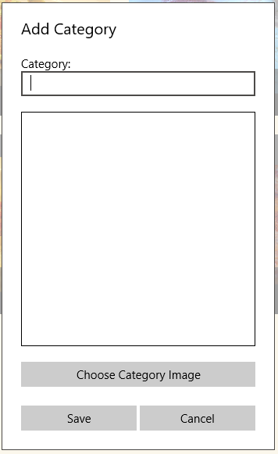 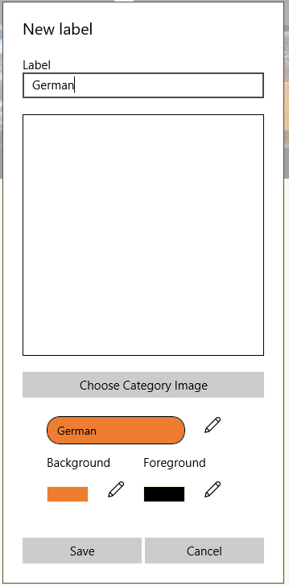

## Modify a category

To change or delete a tile you need to switch into edit mode by clicking the change button. In change mode, the app shows pushbuttons for editing and deleting tiles:

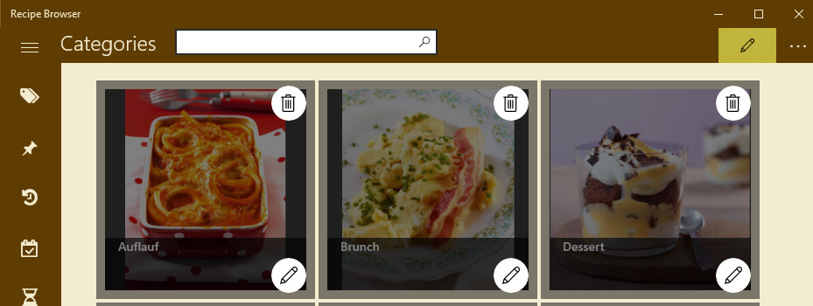

You can delete categories only if they do not contain any recipes.

# Secondary functions

The “Three-Dots” menu gives access to the secondary functions:

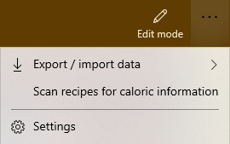

## Settings

By choosing the function *Settings* you can make the following changes.

* Change the theme

|  |  |
| --- | --- |
|  |  |
| Light | Dark |

Changing the theme takes effect only after restarting the app.

* Change the startup folder. If you have moved the recipe collection to a different location, you can specify the new location with this function.
* Log application events. This function is used for analysis and should normally be turned off.

## Export / import data

The app works with different data sources:

* Most importantly, with the *recipes*. These are stored in PDF-format or in „Rich Text Format“(RTF).
* *Additional information*: As soon as you mark a recipe as “prepared”, the app creates an XML file with the same name to store the preparation date as well as the number of times a recipe was prepared.
* *Notes*: You can enter additional notes for recipes in PDF format. These are stored as RTF files.
* The *history* contains all preparation dates.
* The *database* stores calorie specifications, labels, and the assignments of labels to recipes.

In contrast to the history and the database, the recipes, additional information, and notes are stored in the startup folder. If several users or computers have access to this folder, the recipes, additional information and notes are available to everyone who has access.

However, the history and the database are stored in the application data of each user. It is still possible to transfer the data between users or computers by exporting and importing:

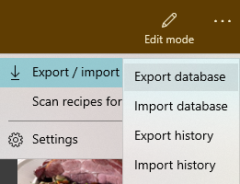

In all cases you will be asked to choose a file first. When importing data, you can decide if you want to replace the current data, or if you want to merge the current data and the data chosen for import:

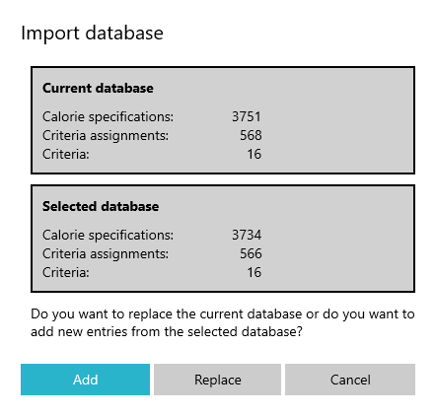

## Caloric Information

The app scans all recipes in PDF format for caloric information (“xx kcal”). If found, the caloric information is displayed in the recipe list. The scan is performed once for each recipe as soon as it is displayed for the first time.

With the menu function “Scan recipes for caloric information” you can scan all recipes for caloric information, and thereby initialize the database. This may take some time as the scan of each recipe can take several seconds. You can cancel the scan anytime. When continued, the scan resumes where it left off.